| No. of Pages | **8** |
| --- | --- |
| No. of Questions | 7 |

**Department of Computer Science and Engineering**

**FINAL EXAMINATION SUMMER 2018**

**CSE421/EEE465: Computer Networks**

**Total Marks: 100 Time Allowed: 2 Hours 30 minutes**



* Answer **Any** **Five (5)** questions out of **Seven (7)** questions.
* Figure in bracket [] next to each question indicates marks for that question.



###### Question No. 1

1. An organization is given the block 193.0.0.0/8. The organization takes this block to distribute to four sub-networks and 2 WAN-Links as shown in the **Figure No. 1** below. Show how you can efficiently distribute the given block to create the required subnets using VLSM. Show basic calculations. [12 marks] 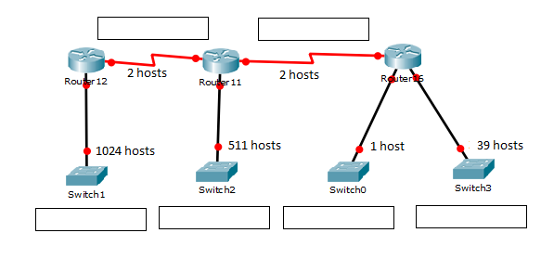
2. The network administrator was asked to create a default route for the network. However, when configuring, he enters the following two commands as shown in **Figure No. 2** below, configuring two static routes via two different exit interfaces. Why did he do that? And what does the value ‘10’ in the second command stand for? [5 marks]





1. Explain why static routes are preferable for small networks but not larger networks. [3 marks]

###### Question No. 2

1. Suppose that the data bytes of an original datagram are 5020 bytes, which includes 20 bytes of header. The datagram is to be sent from PC1 to PC2. The datagram has to go through the network R1 –R2. The network between R1 and R2 only allows maximum data frame size of 800 bytes. [3+3+3 marks]
2. How many fragments will the router R1 have to create to send the data through the link to R2?
3. What is the last fragment size including header?
4. And what is the fragment offset and more fragment bit of the 2nd fragment?
5. What is the purpose of TTL in network layer header? What happens to the TTL of a packet when it moves from one router to another? [3+2 marks]

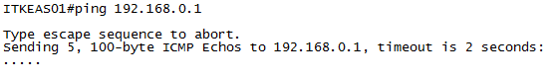

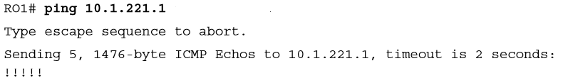



1. Refer to the **Figure No. 3**, which shows two output of PING from two devices. What type of devices are we pinging from? And what is the difference between the two ping outputs shown? [4 marks]
2. In trace route, which field does the original sender look at to decide that the trace route packet has reached its destination? [2 marks]

###### Question No. 3

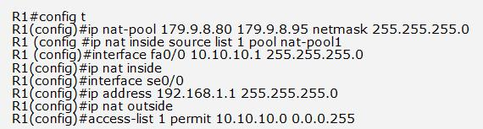



1. Refer to the commands shown in the **Figure No. 4** above. [2+2 marks]
2. Which host or hosts will be allowed to be translated to a public address when it leaves the router?
3. Translation is done by NAT or PAT, explain your answer.
4. What is the disadvantage of using NAT? [2 marks]
5. For what type of devices, DHCPv4 is not recommended? [2 marks]
6. Refer to the table shown in the **Figure No.5** below. What is the name of the table? Explain the last line of the table. What type of server is the destination? [5 marks]

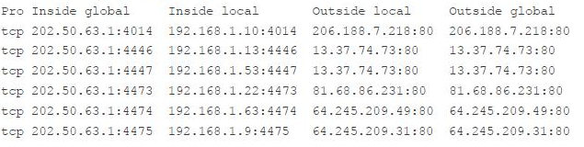



1. Refer to **Figure No.6&7** below; [2+2+3 marks]
   1. Find the reason/s why the dhcp process is not working for Host C.
   2. Host A and Host B are unable to go outside of their own network, why?
   3. ARP for the DNS server is not going through the router HQ, how can we solve it?

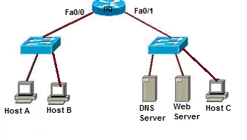





###### Question No. 4

1. When a host in IPv6 joins a network, it can configure itself, what is the name of this process? Describe the steps of this process. [1+3 marks]
2. Assume a host with Ethernet address (F5-A9-23-11-9B-E2)16 has joined the network. What would be its global unicast address if the global unicast prefix of the organization is 3A21:1216:2165 and the subnet identifier is B247. [4 marks]
3. Write down the comparison between IPv4 and IPv6 header. [5 marks]
4. One of the functions of ICMPv6 is DAD, what is it for and how is it done? [4 marks]
5. What is tunneling in IPv6 and what is it used for? [3 marks]

###### Question No. 5

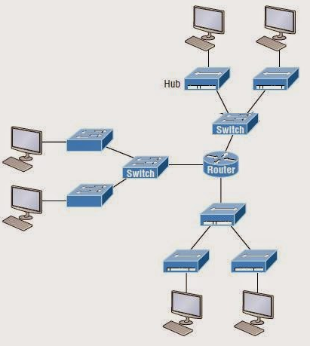



1. How many collision domains and broadcast domains are there in the topology shown in the above **Figure No. 8**? What if we replace the Router with a Layer 3 switch, which number will change? [5 marks]
2. State the disadvantages of Cut Through switching over Store and Forward switching. [3 marks]
3. Refer to **Figure no. 9** below. The network administrator configures both switches as displayed. However, host C is unable to ping host D and host E is unable to ping host F. What actions should the administrator take to enable this communication? [4 marks]

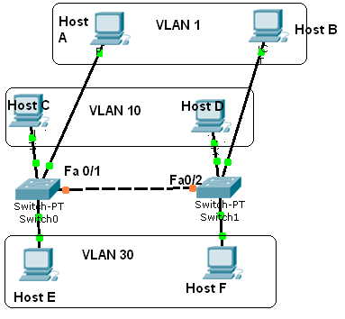









1. Refer to the above commands and output shown in **Figure no. 10**,
2. Will an outsider using a PC with the MAC address 0123.2366.b321 be able to send data frames through this port? Explain your answer.
3. What will happen to the port if the outsider does try to send data using that PC?
4. The outsider now turns the switch off and then on again. He connects to fa0/13 port and tries to send harmful data; will he be able to or not? [3+2+3 marks]

###### Question No. 6

1. In the network shown in **Figure no. 11**, PC1 sends an ARP request for the Server’s MAC address. How will SW1 switch and SW2 switch handle this frame? [4 marks]

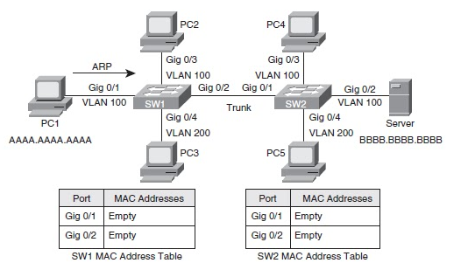



1. When voice from the IP Phone 0 and data from PC2 is entering port fa0/1 of Switch 1 in **Figure No. 12**, how will the switch differentiate between both frames to prioritize the voice frames? [3 marks]

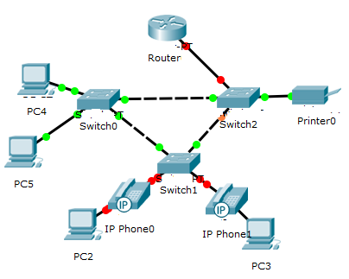

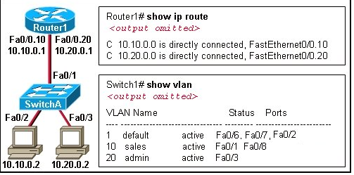



1. Refer to the output shown in the above **Figure no. 13**, the two hosts have no connectivity, why? [4 marks]







1. 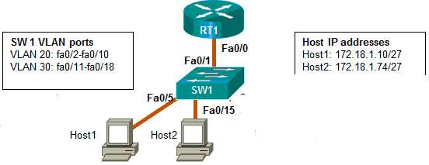Refer to the commands and topology shown in **Figure no.14 &15** , [6 marks]
   1. Host 1 and Host 2 have no connectivity, what are reasons?
   2. What is the purpose of the command “**encapsulation dot1q 10**’’?
2. Refer to the **Figure No. 16** below. For inter VLAN communication we need a router. But in the figure below what is used instead of the router? And what kind of interfaces do we use in SW1 instead of the sub interfaces of a router? [3 marks]

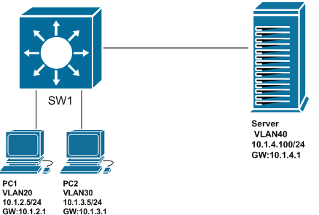

###### Question No. 7

1. How can we counter the effect of implicit deny? [2 marks]
2. Referring to the **Figure no. 17** below, write a named standard ACL that will allow all hosts from the Production Department (200.20.20.128/25 network) to have access only to the Web server but not the HR Server. All the other departments should have access to the servers. Do not forget to place the ACL. [6 marks]
3. Referring to the **Figure no. 17** below, how will the placement change if you write the same ACL of question 7(b) in Singapore Router? [3 marks]

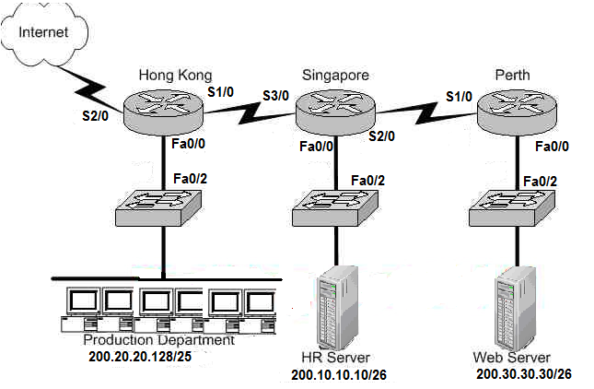



1. Refer to **Figure no. 17** above, write a standard ACL that will only allow all hosts of the 200.20.20.0/26 network except PC (IP: 200.10.10.10) to telnet into the Singapore Router? [3+2 marks]

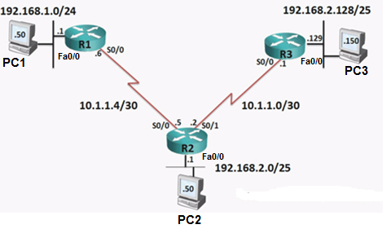

1. Refer to **Figure no. 18**, write a named standard ACL that will not allow PC1 to have any access to the 192.168.2.0/25 network. But all other hosts of 192.168.1.0/24 are allowed access to the 192.168.2.0/25 network. Do not forget to place the ACL. [4 marks]



##### THE END